Snowflake to Power BI Hands-On
Swiggy Food Delivery Sales: Data Loading, Cleaning and Dashboard

1. Snowflake Environment Setup

1.1 Create Database
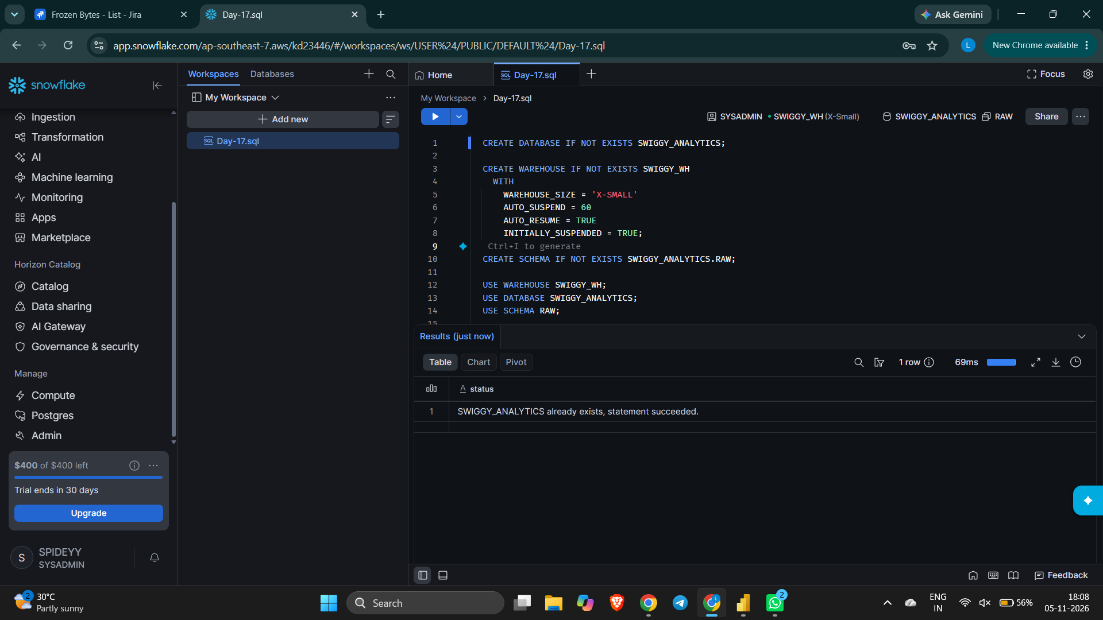

1.2 Create Warehouse
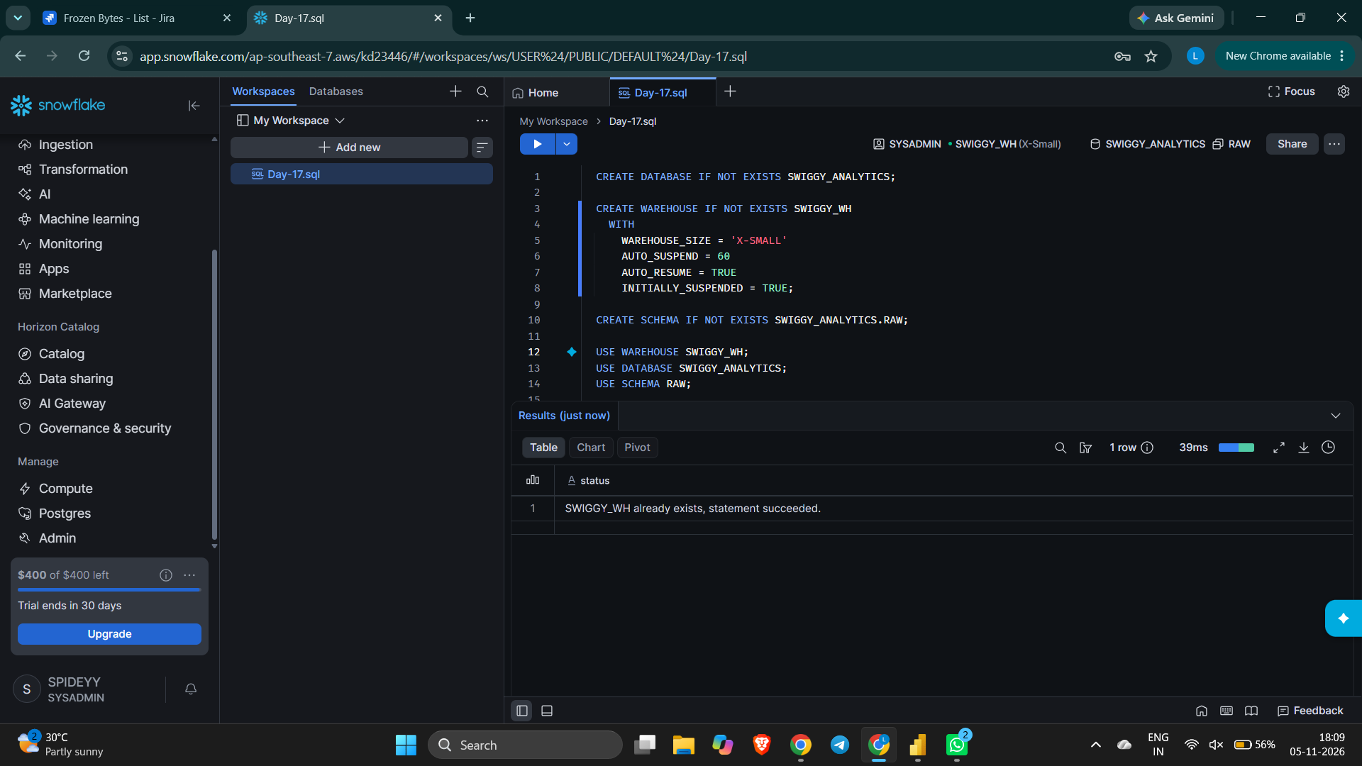

1.3 Create Schema
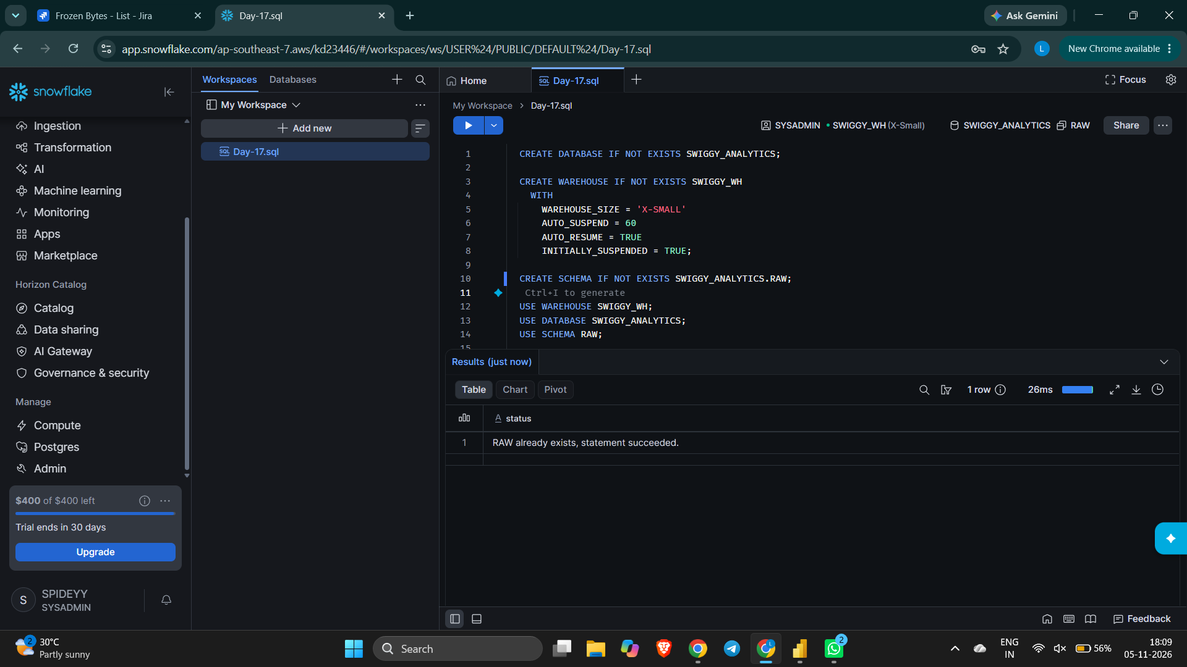

1.4 Set Working Context (Warehouse, Database, Schema)
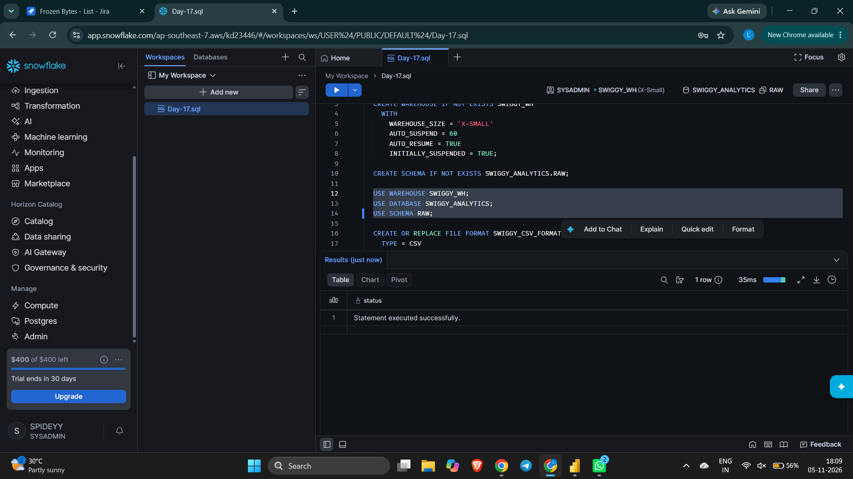

2. Data Loading Configuration in Snowflake

2.1 Create CSV File Format
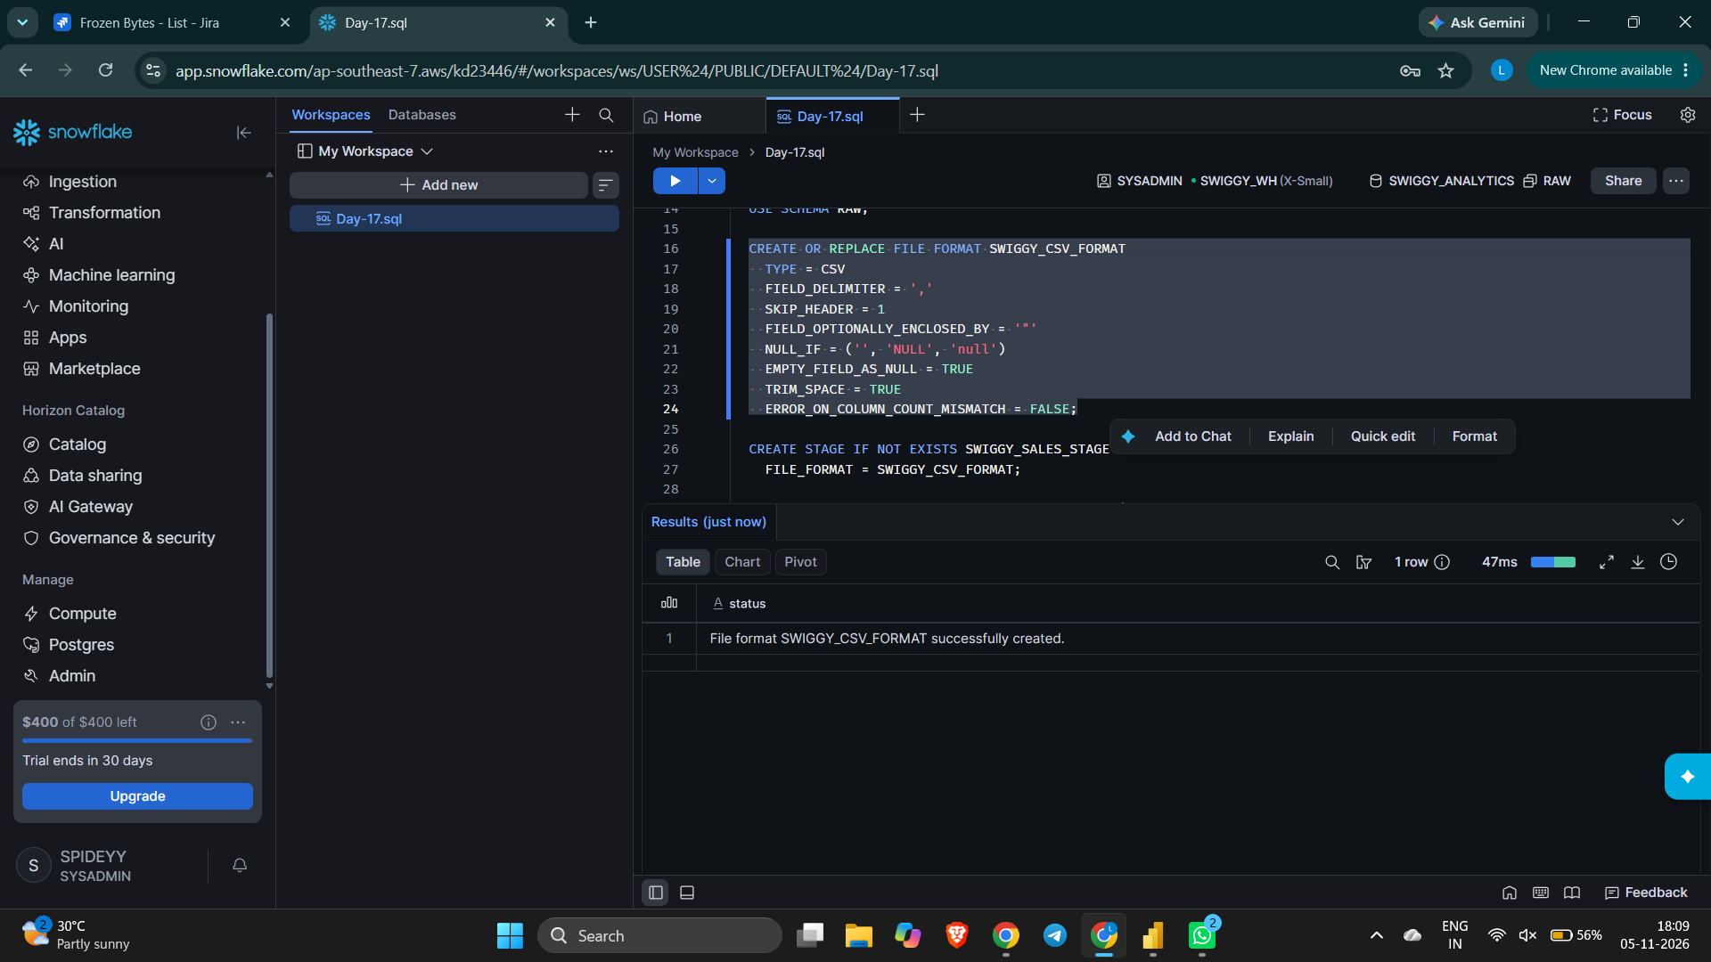

2.2 Create Internal Stage
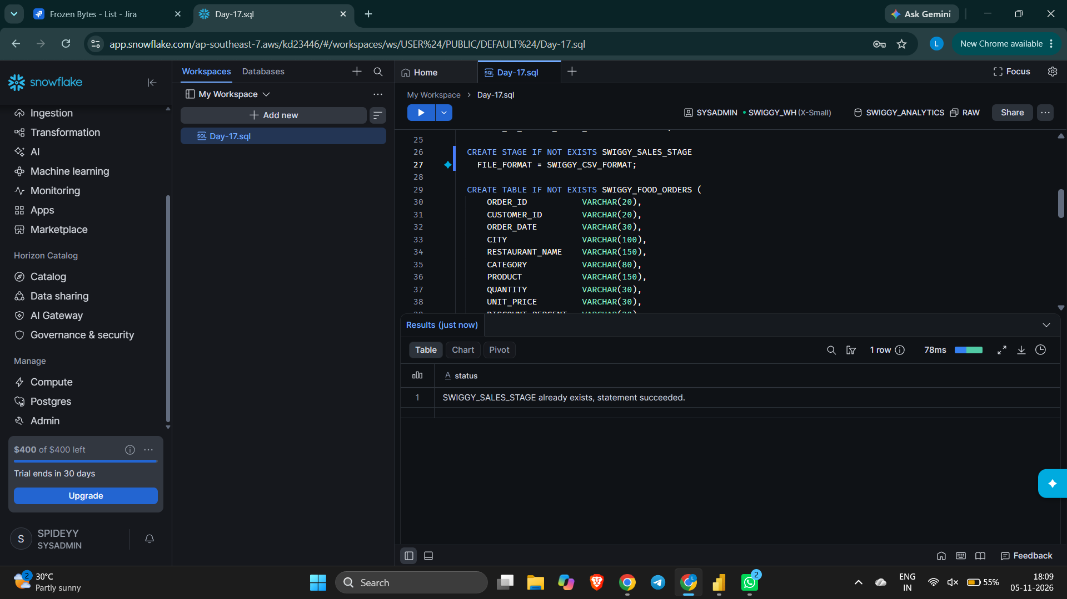

2.3 Create Target Table
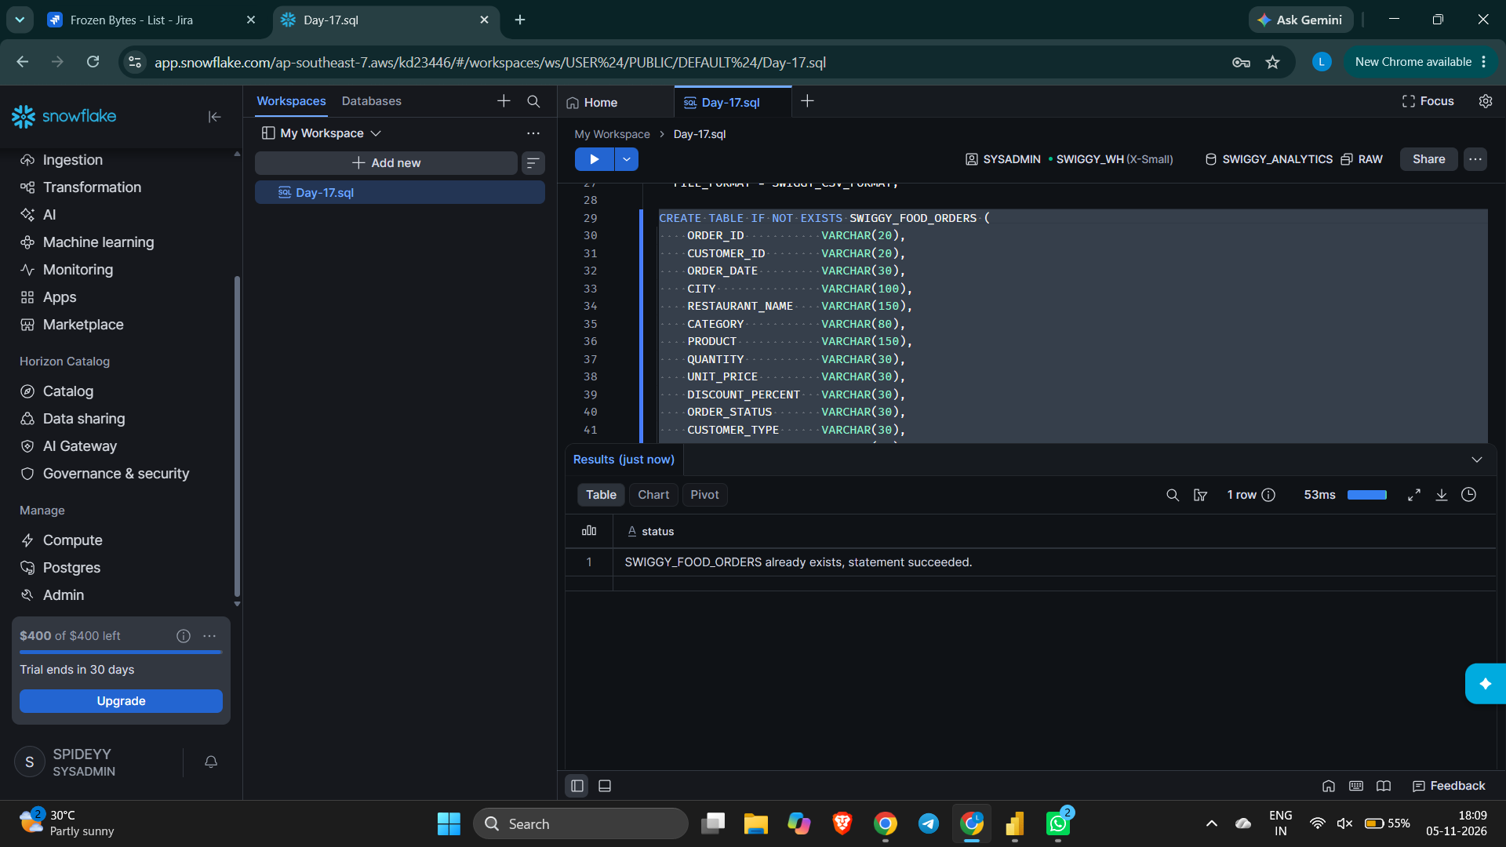

2.4 Verify Objects (SHOW and DESC Commands)
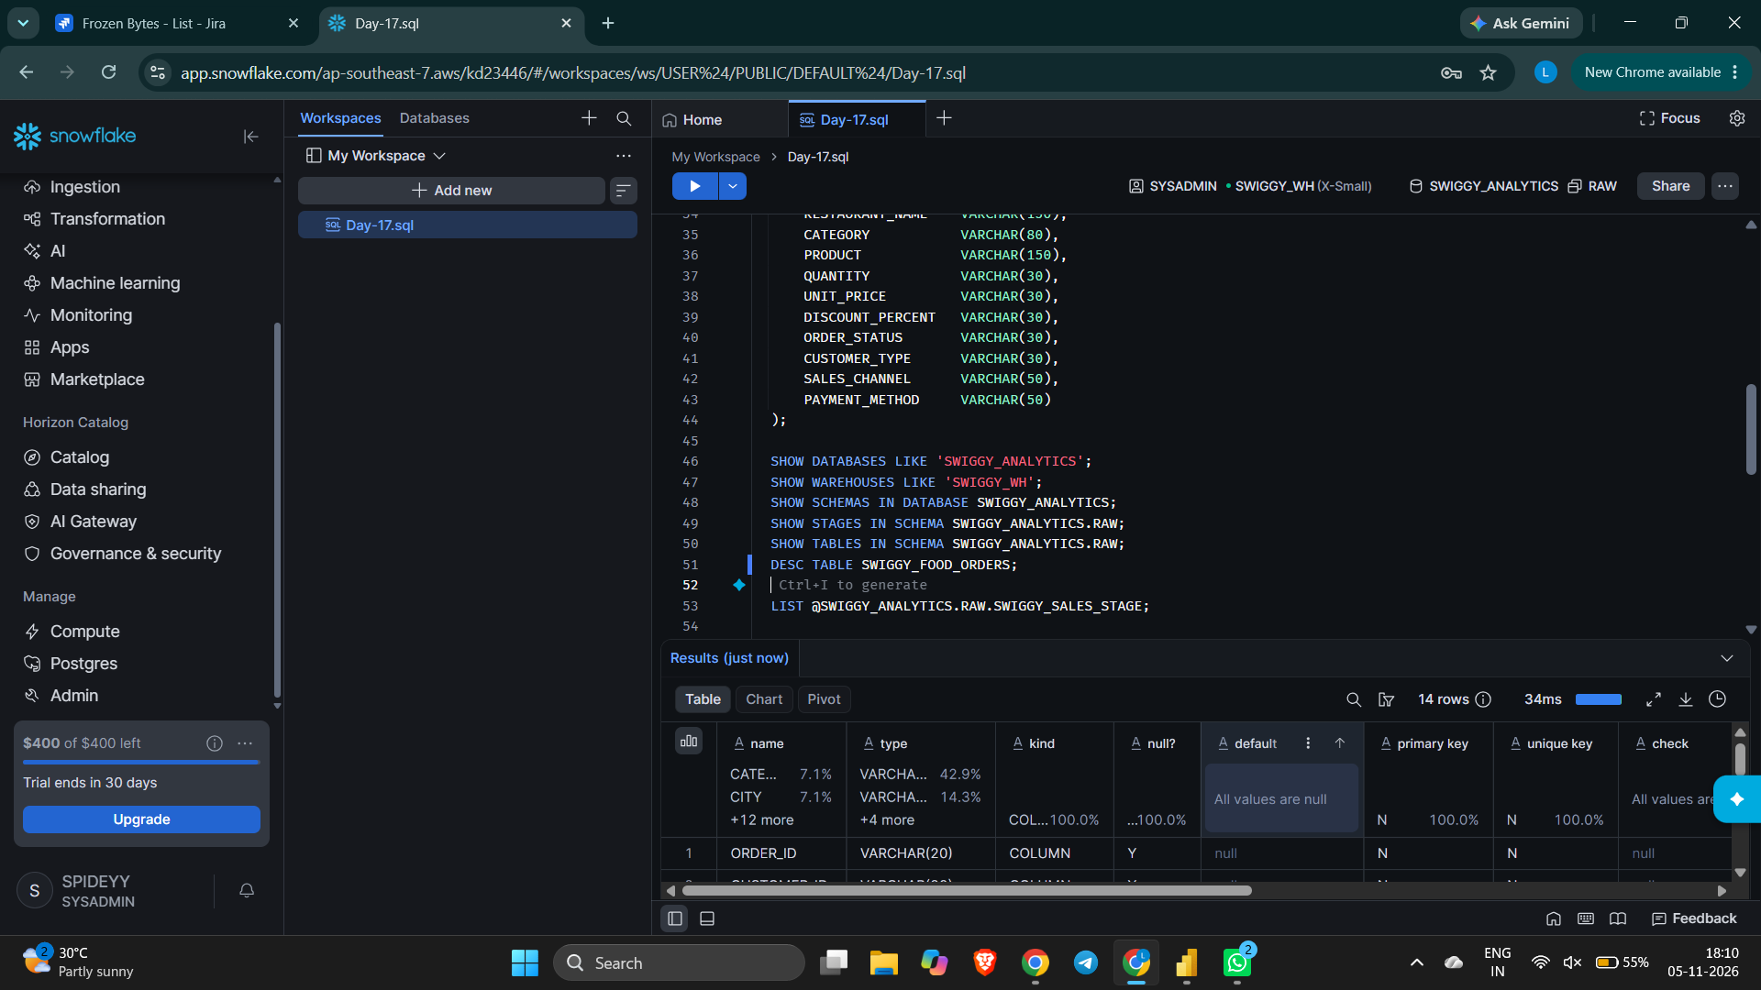

3. Loading Data into Snowflake

3.1 Upload CSV File to the Stage
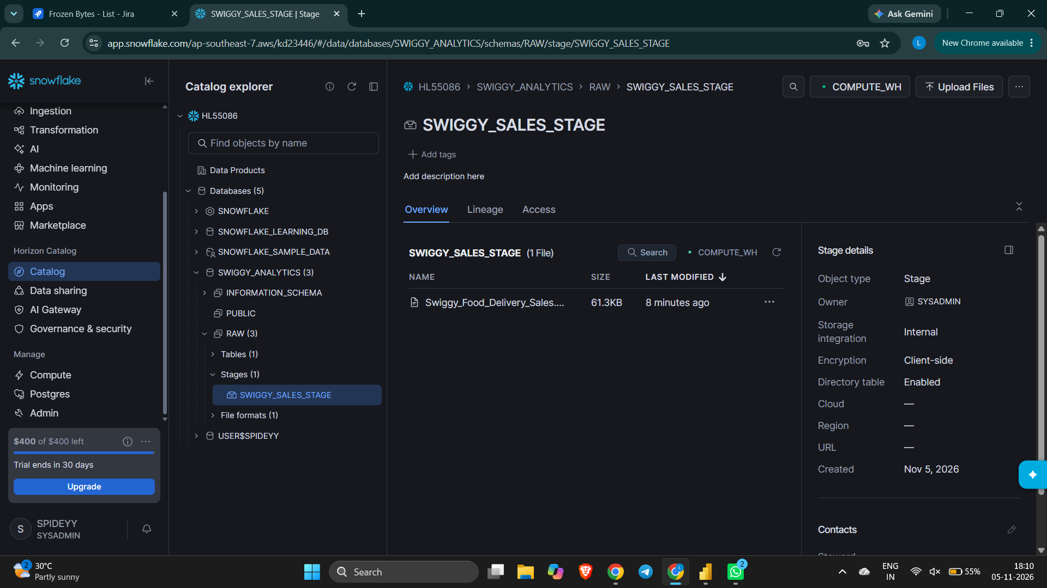

3.2 List Files in the Stage
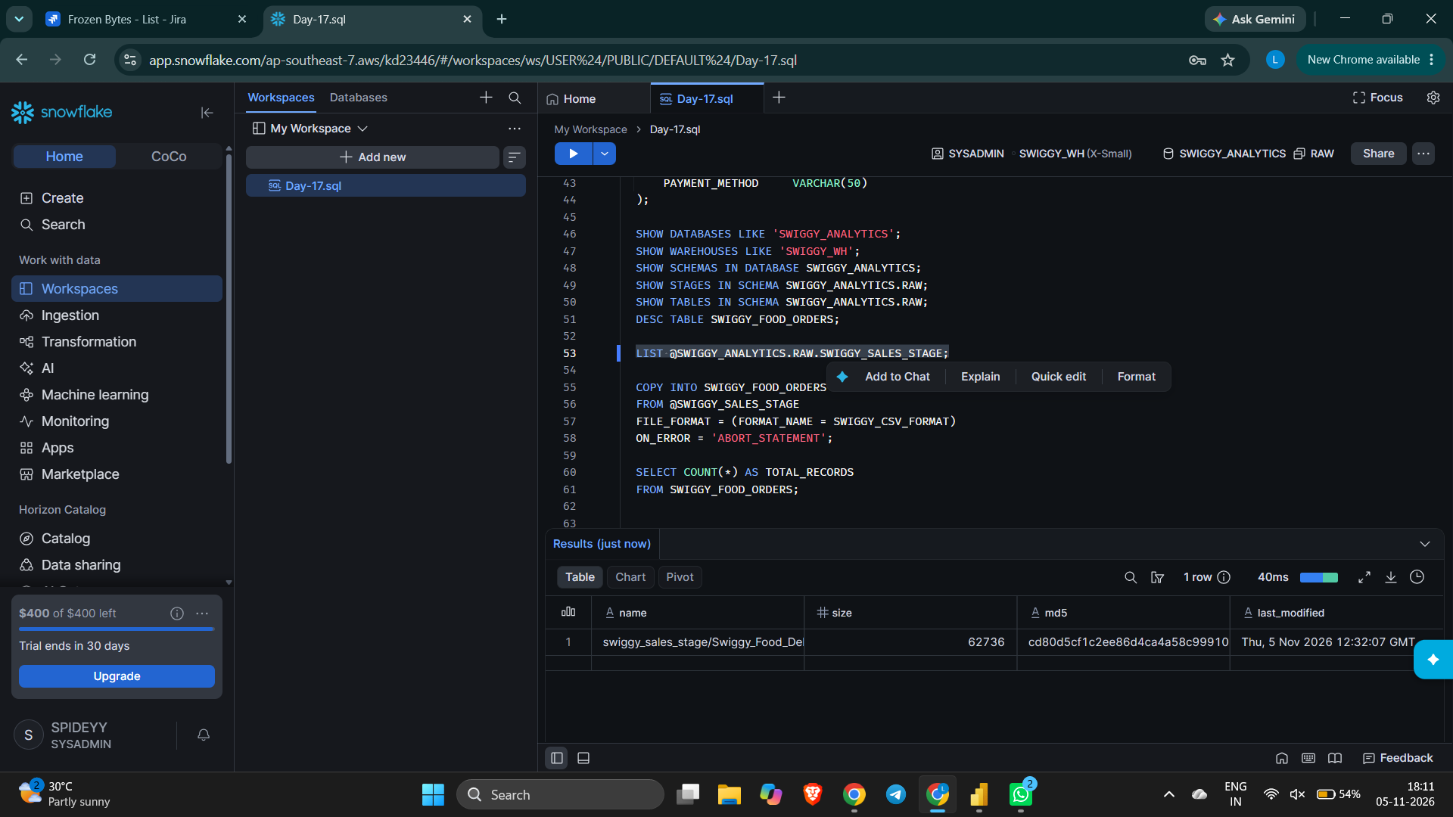

3.3 Copy Data from Stage into Table
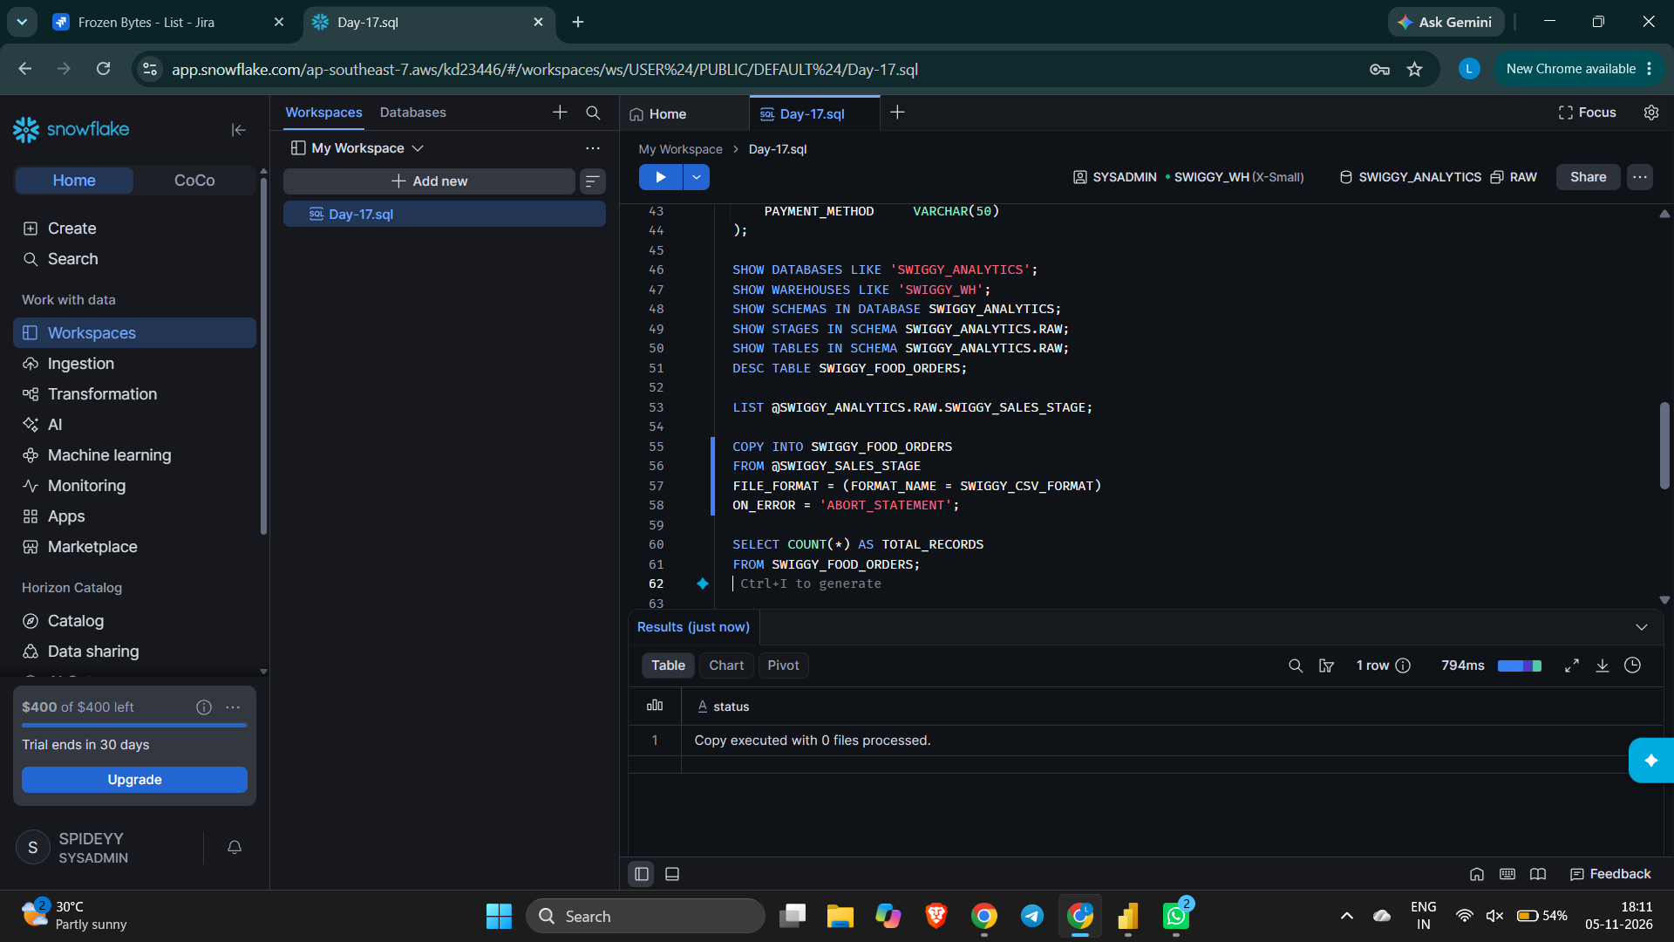

3.4 Validate Total Record Count
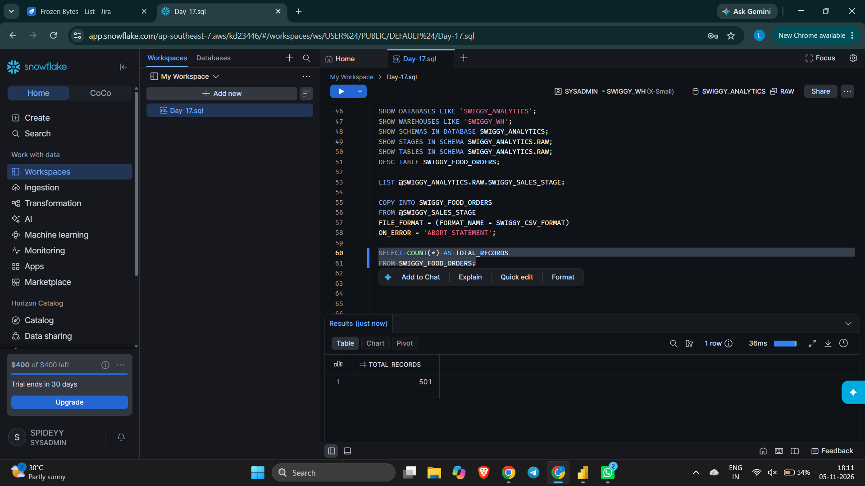

4. Connecting Power BI to Snowflake

4.1 Select Snowflake as the Data Source
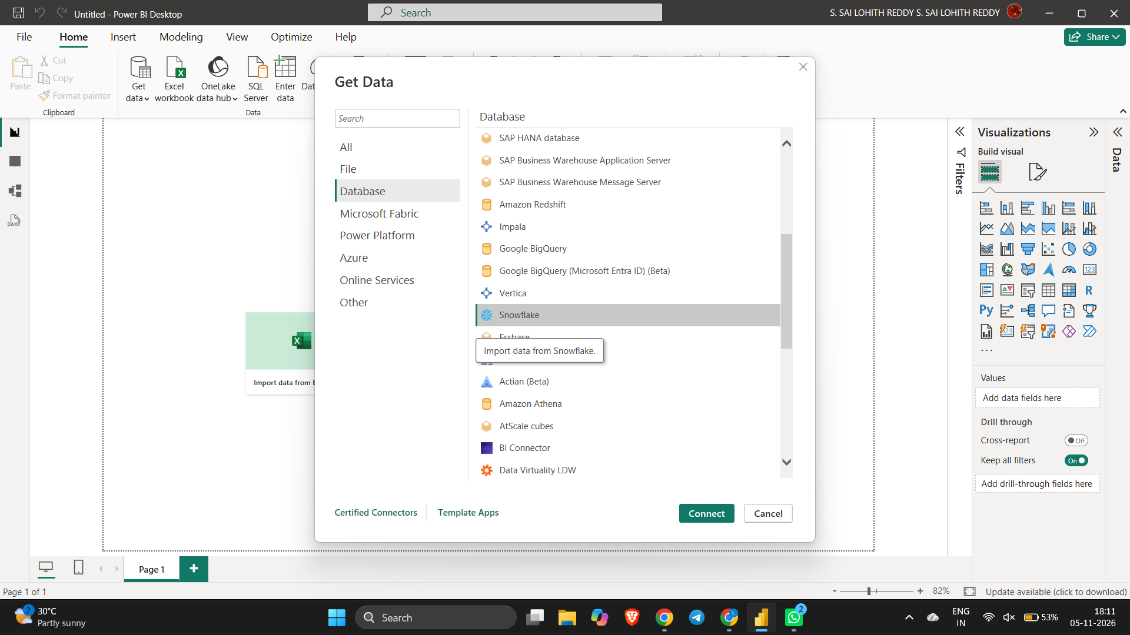

4.2 Enter Server and Warehouse Details
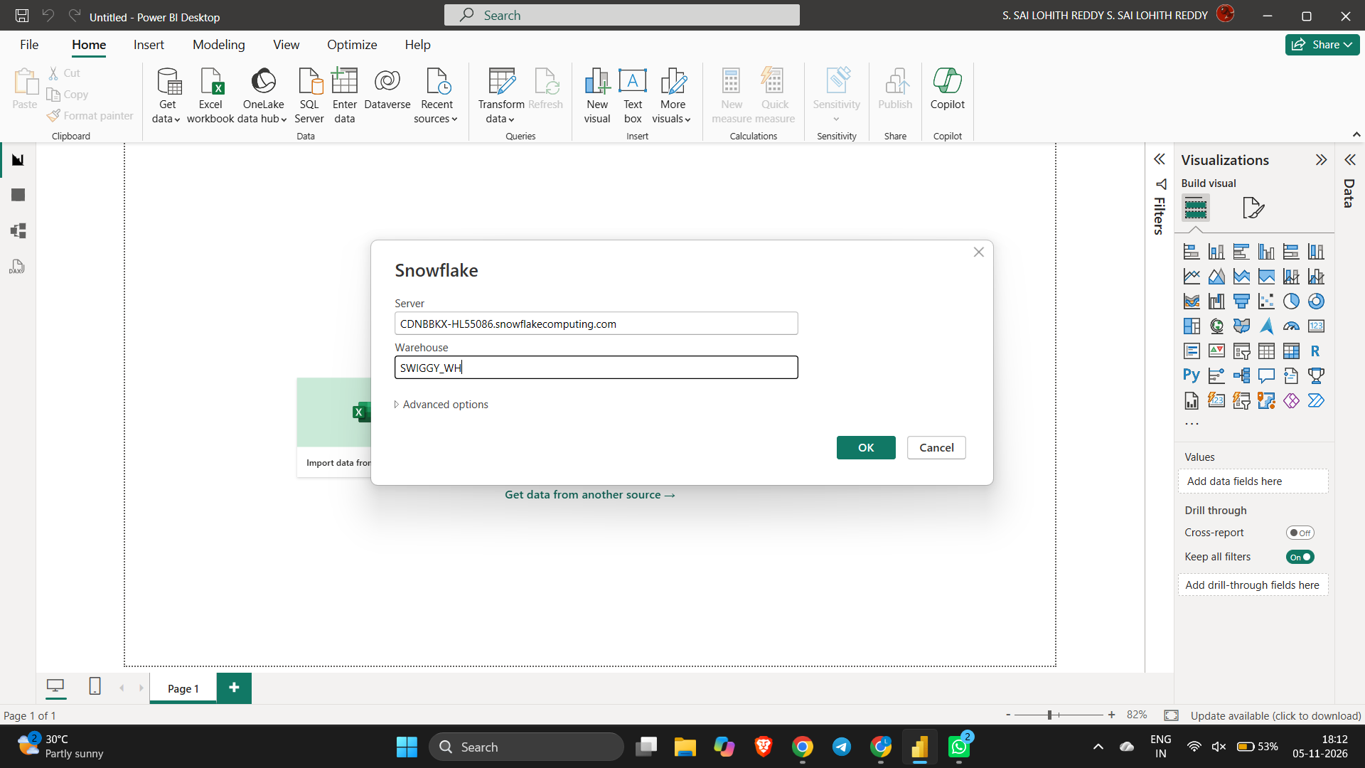

4.3 Select the Table in Navigator
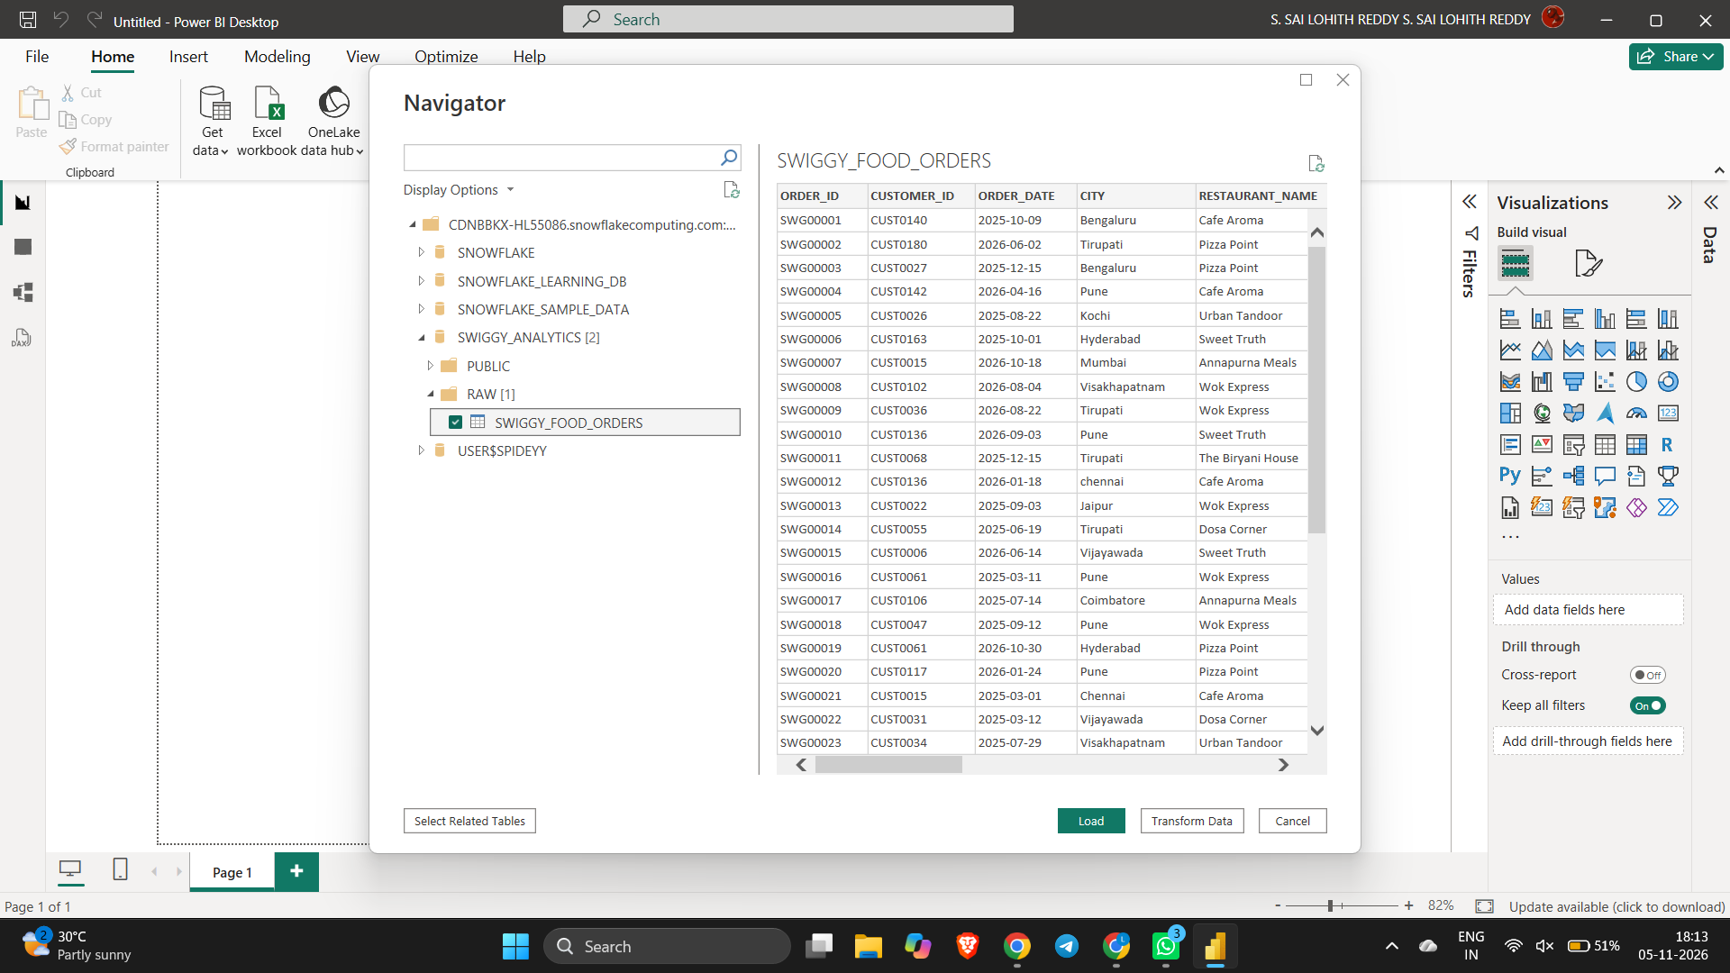

4.4 Choose Import Connection Mode
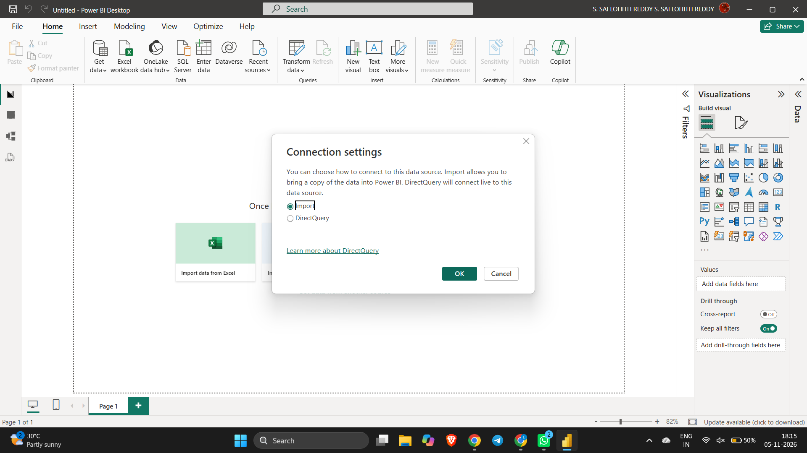

5. Data Cleaning in Power Query Editor

5.1 Trim, Clean and Capitalize Text Columns
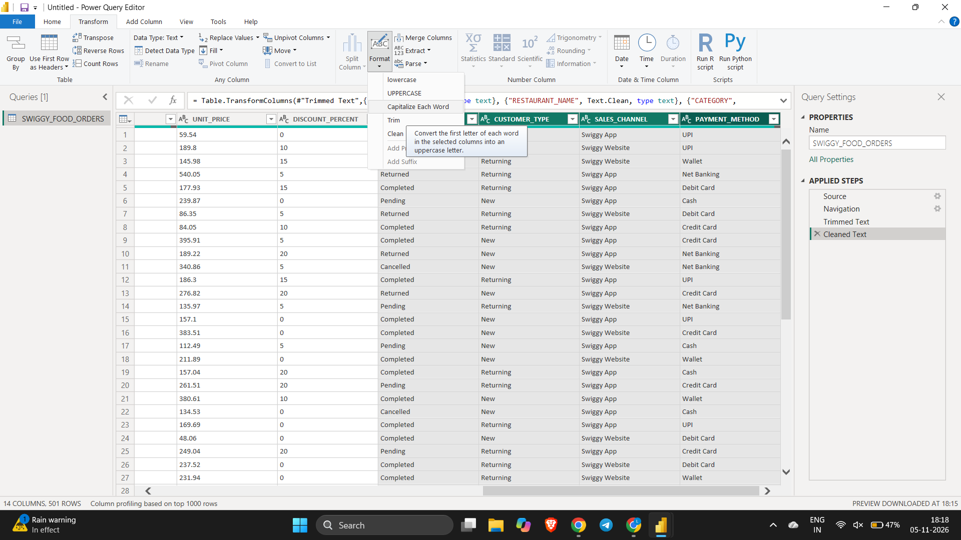

5.2 Replace Values, Remove Duplicates and Fix Errors
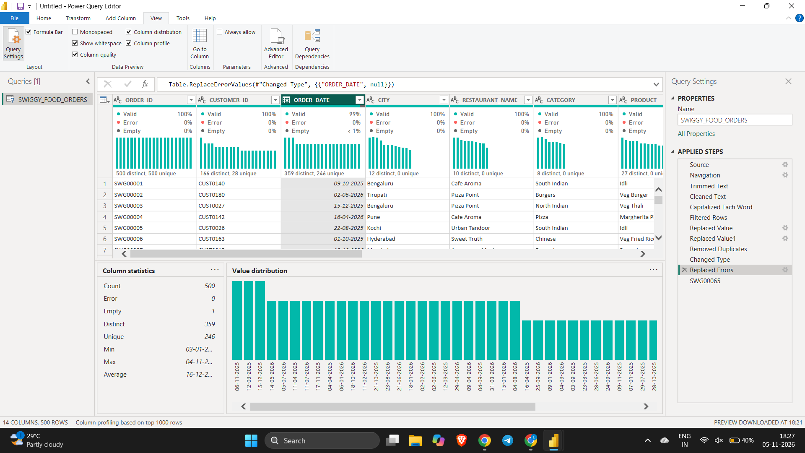

5.3 Apply Changes and Load Data
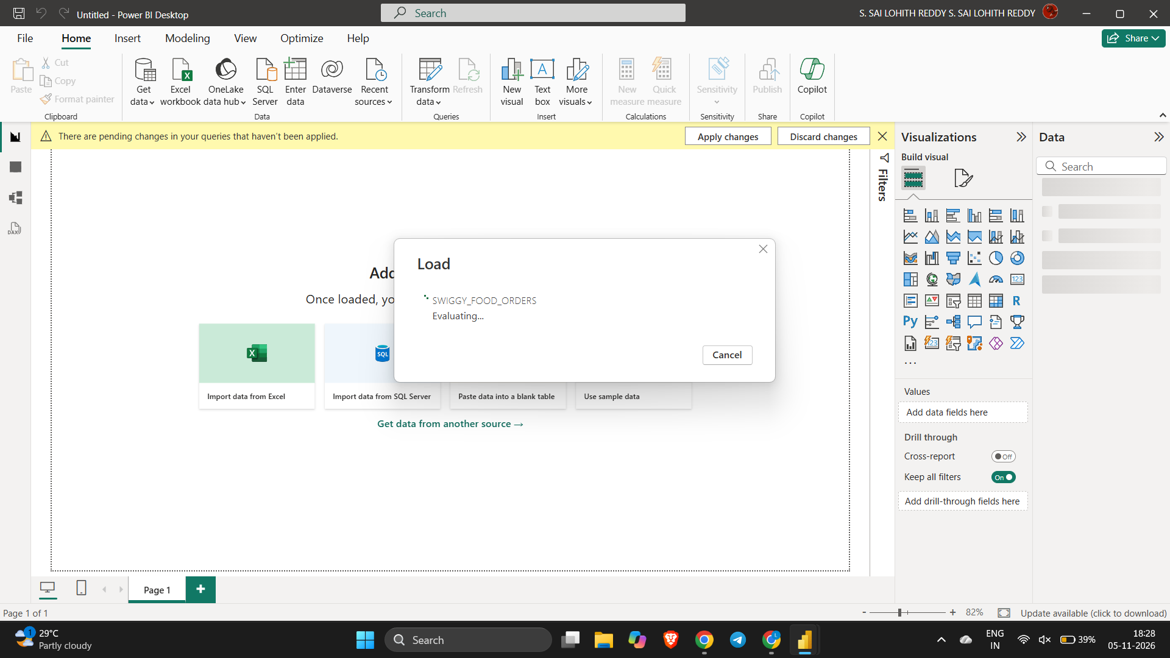

6. Final Dashboard

6.1 Swiggy Sales Analysis Dashboard in Power BI


